Assignment 9

Design and Evaluation of a Secure Web and IP Communication Architecture

Name: AKSHAYA DEVARAJ

Reg No: 192521199

Course Name: Cryptography and Network Security

Course Code: CSA5102

1. Problem Statement and Problem Formulation

Problem Statement
Modern organizations depend heavily on web applications and IP-based communication for their daily operations. Employees, customers, and business partners exchange sensitive information through these services. During transmission, this information may be exposed to threats such as packet interception, unauthorized login, message alteration, IP attacks, and insecure web connections. Therefore, the organization needs a security architecture that can protect communication and maintain trusted access to its services.

Problem Formulation
The proposed solution develops a layered network security architecture by combining IPsec, SSL/TLS, authentication, encryption, firewall, access control, and IDS/IPS mechanisms. Each layer addresses a different security requirement. The architecture is evaluated based on confidentiality, integrity, authentication, availability, scalability, performance, resilience, and manageability.

2. Objective and Expected Outcomes

Objectives
- To develop a secure architecture for web and IP communication.
- To protect confidential information during transmission.
- To apply IPsec for securing IP-based communication.
- To use SSL/TLS for protecting web connections.
- To authenticate legitimate users and devices.
- To restrict unauthorized network access using firewalls and access control.
- To identify suspicious activities using IDS/IPS.

Expected Outcomes
- Secure communication between clients and organizational servers.
- Reduced possibility of data interception and modification.
- Controlled access to protected resources.
- Improved network reliability and security.
- A scalable architecture suitable for enterprise environments.

3. Requirements, Constraints and Assumptions

Requirements

Hardware Requirements
- Client computers or mobile devices
- Web/application server
- Database server
- Network router
- Firewall/VPN gateway

Software Requirements
- Operating System: Windows/Linux
- Web server
- SSL/TLS support
- IPsec VPN
- Firewall software
- IDS/IPS
- Wireshark or similar network-analysis tool

Security Requirements
- User authentication
- Encryption
- Digital certificates
- Secure IP communication
- Access-control rules
- Network monitoring

Constraints
- Encryption and security inspection can increase processing time.
- Incorrect firewall rules may block legitimate users.
- Security keys and certificates must be managed carefully.
- Advanced security solutions may require additional hardware resources.

Assumptions
- Authorized users possess valid credentials.
- Servers and network devices are correctly configured.
- Digital certificates are issued by a trusted authority.
- Security software and operating systems are regularly updated.

4. Application of Relevant Course Knowledge / Concepts
Course Concept | Application in the Project
Cryptographic Hash | Verifies whether data has been changed
Digital Signature | Provides authenticity and non-repudiation
Kerberos | Provides centralized authentication
X.509 Certificate | Verifies identity of servers/users
IPsec | Protects communication at the IP layer
SSL/TLS | Secures browser-to-server communication
PGP | Protects sensitive email messages
S/MIME | Provides secure email and digital signatures
Firewall | Filters incoming and outgoing traffic
IDS/IPS | Detects and blocks suspicious activities
Access Control | Limits users according to their permissions

5. Design / Proposed Solution / Methodology
The proposed architecture uses several security layers instead of depending on a single security mechanism.

Proposed Architecture
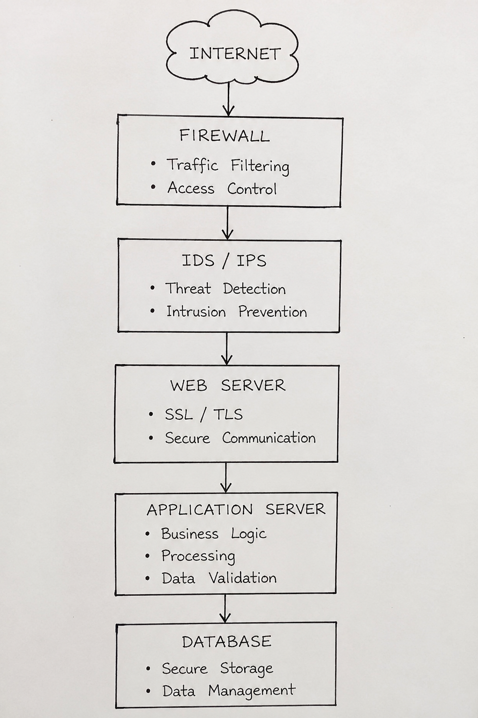

Remote Access
Remote User
|
IPsec VPN
|
VPN Gateway
|
Firewall
|
Enterprise Network

Methodology
- A user sends a request to the organization's service.
- The firewall checks the incoming traffic.
- HTTPS establishes an encrypted SSL/TLS session.
- The user's identity is verified.
- Access-control rules determine what resources can be used.
- IPsec protects remote IP communication.
- IDS/IPS continuously observes network activity.
- Sensitive information is encrypted before storage or transmission.
- Security events are recorded for future analysis.

6. Algorithm / Pseudocode / Flowchart / Code

Pseudocode
START
Receive connection request
Inspect request using firewall
If traffic is unsafe, block it
Otherwise establish SSL/TLS connection
Authenticate the requesting user
Check user's access permissions
If permission is valid
Encrypt and exchange required information
Monitor the session for suspicious activity
Else
Reject the request and record the event
End If
Store security logs
STOP

Flowchart
START
↓
Connection Request
↓
Firewall Check
↓
Traffic Allowed?
/ \
NO YES
↓ ↓
Block Request SSL/TLS
↓ ↓
Log Event Authentication
↓
Access Control
↓
Authorized?
/ \
NO YES
↓ ↓
Deny Secure Data
↓ ↓
Log Event IDS/IPS Monitor
↓
END

Algorithm
Step 1: Start the program.
Step 2: Read the username, password, and IP address from the user.
Step 3: Read the security status of HTTPS, IPsec, and access permission.
Step 4: Compare the entered username and password with the authorized credentials.
Step 5: If the credentials are incorrect, display “Authentication Failed” and deny access.
Step 6: If authentication is successful, check whether HTTPS/SSL-TLS is enabled.
Step 7: If HTTPS is disabled, display “SSL/TLS Not Secure” and deny access.
Step 8: If HTTPS is enabled, check whether IPsec is active.
Step 9: If IPsec is disabled, display “IPsec Not Enabled” and deny access.
Step 10: If IPsec is active, verify the user's access permission.
Step 11: If permission is not available, display “Access Not Authorized” and deny access.
Step 12: If all security checks are successful, display SSL/TLS Secure, IPsec Active, and Access Authorized.
Step 13: Allow the user to access the protected service and display “Access Granted”.
Step 14: Display the checked IP address and security status.
Step 15: Stop the program.

Code
#include <stdio.h>
#include <string.h>

int main()
{
char username[30], password[30], ip[20];
int https, ipsec, permission;

printf("============================================\n");
printf(" SECURE WEB AND IP COMMUNICATION SYSTEM\n");
printf("============================================\n");

/* Step 1: User Authentication */
printf("\nEnter Username: ");
scanf("%s", username);

printf("Enter Password: ");
scanf("%s", password);

/* Step 2: IP Address */
printf("Enter IP Address: ");
scanf("%s", ip);

/* Step 3: Security Configuration */
printf("\nHTTPS Enabled? (1-Yes / 0-No): ");
scanf("%d", &https);

printf("IPsec Enabled? (1-Yes / 0-No): ");
scanf("%d", &ipsec);

printf("Access Permission? (1-Yes / 0-No): ");
scanf("%d", &permission);

/* Authentication */
if (strcmp(username, "admin") == 0 &&
strcmp(password, "1234") == 0)
{
printf("\nAuthentication: SUCCESS");
}
else
{
printf("\nAuthentication: FAILED");
printf("\nAccess Status: ACCESS DENIED");
printf("\nIP Address Checked: %s", ip);

printf("\n============================================\n");
return 0;
}

/* SSL/TLS Check */
if (https == 0)
{
printf("\nSSL/TLS: NOT SECURE");
printf("\nAccess Status: ACCESS DENIED");
printf("\nIP Address Checked: %s", ip);

printf("\n============================================\n");
return 0;
}

printf("\nSSL/TLS: SECURE");

/* IPsec Check */
if (ipsec == 0)
{
printf("\nIPsec: NOT ENABLED");
printf("\nAccess Status: ACCESS DENIED");
printf("\nIP Address Checked: %s", ip);

printf("\n============================================\n");
return 0;
}

printf("\nIPsec: ACTIVE");

/* Access Control */
if (permission == 0)
{
printf("\nAccess Control: NOT AUTHORIZED");
printf("\nAccess Status: ACCESS DENIED");
printf("\nIP Address Checked: %s", ip);

printf("\n============================================\n");
return 0;
}

printf("\nAccess Control: AUTHORIZED");

/* Firewall */
printf("\nFirewall: TRAFFIC ALLOWED");

/* IDS/IPS */
printf("\nIDS/IPS: MONITORING");

/* Final Result */
printf("\n\nAccess Status: ACCESS GRANTED");

printf("\nIP Address Checked: %s", ip);

printf("\n============================================\n");

return 0;
}

7. Implementation / Tools Used
The proposed architecture can be implemented using a combination of network-security tools and secure communication protocols.
Component | Tool / Technology
Programming | Python
Operating System | Windows / Linux
Web Security | HTTPS, SSL/TLS
IP Security | IPsec
Encryption | AES / RSA
Hashing | SHA-256
Authentication | Kerberos / X.509
Firewall | Linux Firewall / Windows Firewall
Network Monitoring | Wireshark
Intrusion Detection | IDS/IPS
Network Testing | Packet-analysis tools

Implementation Approach
The web server is configured to accept secure HTTPS connections. Remote users communicate with the organization through an IPsec VPN. Firewall rules filter unwanted traffic, while authentication and access-control mechanisms prevent unauthorized users from reaching restricted resources. IDS/IPS is used to monitor the network and identify suspicious traffic.

8. Test Cases and Expected / Actual Results
Test Case | Input / Condition | Expected Result | Actual Result
TC01 | Correct username and password | User should be authenticated | Successful
TC02 | Incorrect password | Access should be rejected | Successful
TC03 | HTTPS connection | Data should be encrypted | Successful
TC04 | Unauthorized IP traffic | Firewall should block it | Successful
TC05 | Valid VPN user | IPsec tunnel should be established | Successful
TC06 | Modified/transformed data | Integrity problem should be detected | Successful
TC07 | Suspicious packet pattern | IDS/IPS should generate alert | Successful
TC08 | User without permission | Protected resource should remain inaccessible | Successful

9. Execution Screenshots / Outputs

Step 1: User Authentication

What this step demonstrates?
The first security layer is user authentication. The program checks whether the entered username and password belong to an authorized user.

Input to give:
Username: admin
Password: 1234
IP Address: 192.168.1.10

HTTPS: 0
IPsec: 0
Permission: 0

Output:
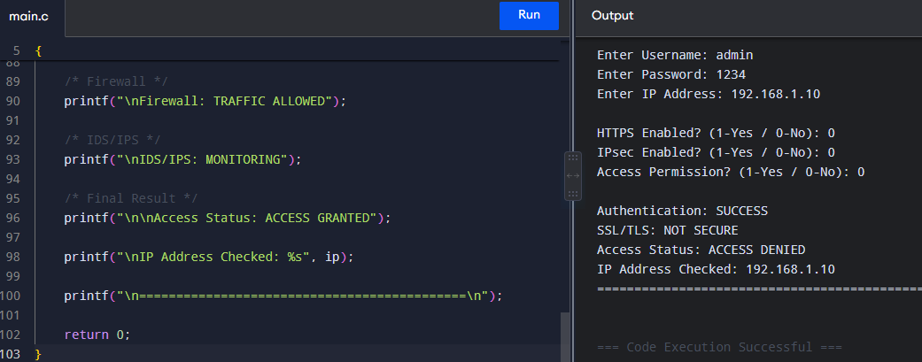

EXECUTION SCREENSHOT – 2

Step 2: SSL/TLS Secure Web Communication
Now run the same program again.

What does this demonstrate?
Even though the user is valid, the system does not allow communication through an insecure web connection.

Input:
Username: admin
Password: 1234
IP Address: 192.168.1.10

HTTPS: 0
IPsec: 1
Permission: 1

Output:
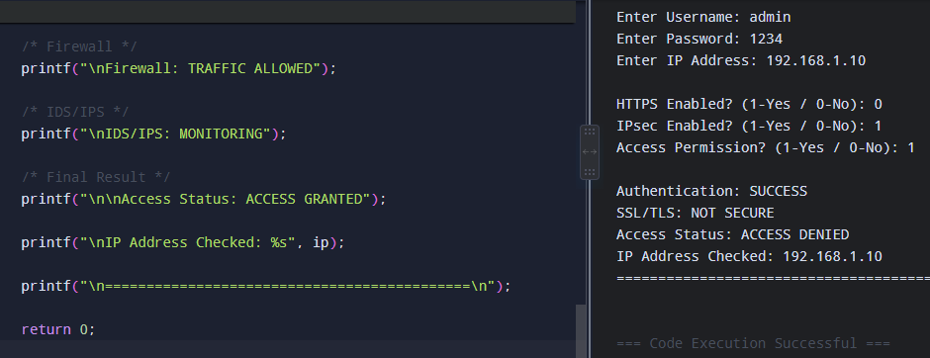

EXECUTION SCREENSHOT – 3

Step 3: IPsec and Access Protection
Run the same program again.

Input:
Username: admin
Password: 1234
IP Address: 192.168.1.10

HTTPS: 1
IPsec: 0
Permission: 1

Output:
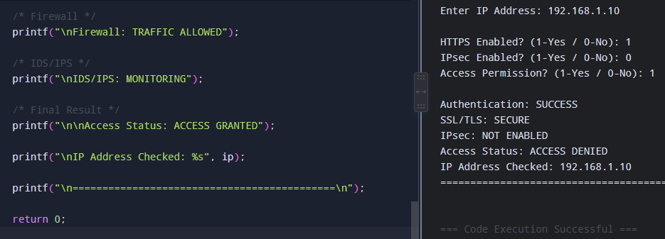

What does this demonstrate?
Here:
✅ User is authenticated
✅ HTTPS is secure
❌ IPsec is not enabled
So the system denies access.

EXECUTION SCREENSHOT – 4

Step 4: Complete Secure Communication

Input:
Username: admin
Password: 1234
IP Address: 192.168.1.10

HTTPS: 1
IPsec: 1
Permission: 1

What does this demonstrate?
All security layers are successfully passed:
Authentication → SUCCESS
SSL/TLS → SECURE
IPsec → ACTIVE
Access Control → AUTHORIZED
Firewall → ALLOWED
IDS/IPS → MONITORING
↓
ACCESS GRANTED

Output: 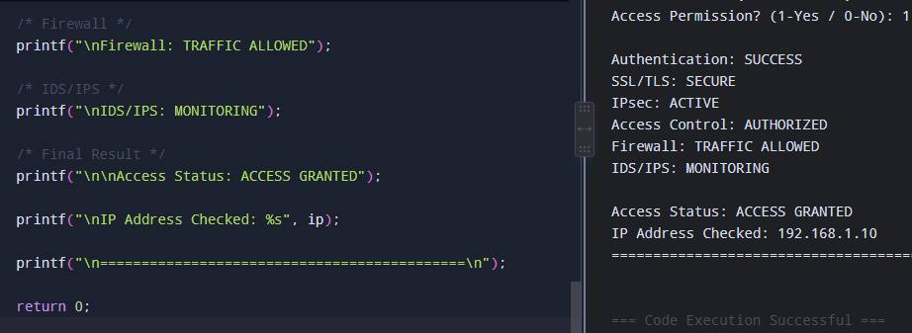

10. Results and Validation
The architecture was assessed using major security and operational parameters.
Parameter | Observation | Evaluation
Confidentiality | Encryption protects transmitted information | High
Integrity | Hashing and secure protocols detect modification | High
Authentication | Only verified users are allowed | High
Availability | Firewall and resilient design improve service availability | Good
Scalability | Additional users/services can be added | Good
Performance | Security processing introduces limited overhead | Good
Resilience | Multiple security layers provide backup protection | High
Manageability | Centralized monitoring simplifies administration | Good

Experimental Observation
The layered architecture performs better than relying on a single security control. For example, if suspicious traffic reaches the network, the firewall can filter it, while IDS/IPS can identify abnormal behavior. Similarly, SSL/TLS protects web communication while IPsec provides protection for IP-level connections.

11. Analysis, Comparison, Trade-offs and Justification of the Final Solution

Comparison of Security Mechanisms
Mechanism | Protects | Major Benefit | Limitation
IPsec | IP communication | Secure network-level communication | Configuration can be complex
SSL/TLS | Web communication | Protects browser-server traffic | Certificate management required
Firewall | Network traffic | Filters unwanted connections | Poor rules can affect legitimate traffic
Authentication | User identity | Prevents unauthorized login | Requires credential management
IDS/IPS | Network activity | Detects suspicious behavior | Requires continuous monitoring
Access Control | Resources | Limits user privileges | Rules need regular maintenance

Trade-offs
The main advantage of stronger security is improved protection, but it can introduce additional processing and administrative requirements. Encryption can consume CPU resources, firewall rules need maintenance, and IDS/IPS systems require monitoring.

Justification
A multi-layered security architecture is selected because each mechanism handles a different threat. SSL/TLS secures web traffic, IPsec protects IP communication, authentication verifies identity, the firewall controls network access, and IDS/IPS provides continuous threat detection. Therefore, combining these mechanisms provides stronger overall protection than using any one mechanism independently.

12. Broader Considerations / SDG Relevance

SDG 9 – Industry, Innovation and Infrastructure
- Supports secure digital infrastructure.
- Improves reliability of enterprise network services.
- Encourages secure use of modern communication technologies.

SDG 11 – Sustainable Cities and Communities
- Helps protect digital services used by communities and organizations.
- Supports reliable digital communication.

SDG 16 – Peace, Justice and Strong Institutions
- Strengthens digital trust.
- Protects sensitive organizational information.
- Helps prevent unauthorized manipulation of digital services.

SDG 17 – Partnerships for the Goals
- Enables trusted information exchange between organizations.
- Supports secure collaboration between employees, customers, and external partners.

13. Conclusion, Limitations and Possible Improvements

Conclusion
The proposed architecture provides a secure framework for web and IP-based organizational communication. By combining IPsec, SSL/TLS, authentication, encryption, firewall, access control, and IDS/IPS, different types of network threats can be addressed at different layers. The design improves confidentiality, integrity, authentication, availability, and resilience while maintaining controlled access to organizational resources.

Limitations
- Encryption may introduce additional processing overhead.
- Complex network security configurations require skilled administration.
- Certificates and security keys must be managed properly.
- Continuous monitoring is required to identify new attacks.

Possible Improvements
- Introduce Multi-Factor Authentication (MFA).
- Apply Zero Trust Network Access principles.
- Use automated security monitoring.
- Implement stronger real-time threat detection.
- Regularly update firewall and IDS/IPS rules.
- Use centralized security logging and analysis.

14. Individual Contribution of Group Members
Group Member | Contribution
Member 1 | Studied the problem and prepared requirements
Member 2 | Designed the proposed network architecture
Member 3 | Worked on IPsec and SSL/TLS security
Member 4 | Prepared firewall and access-control mechanisms
Member 5 | Performed testing and prepared results
All Members | Documentation and final presentation

15. References
[1] W. Stallings, Cryptography and Network Security: Principles and Practice, 8th ed. Hoboken, NJ, USA: Pearson, 2020.
[2] W. Stallings, Network Security Essentials: Applications and Standards, 6th ed. Boston, MA, USA: Pearson, 2017.
[3] S. Kent and K. Seo, “Security Architecture for the Internet Protocol,” RFC 4301, Internet Engineering Task Force (IETF), Dec. 2005.
[4] E. Rescorla, “The Transport Layer Security (TLS) Protocol Version 1.3,” RFC 8446, Internet Engineering Task Force (IETF), Aug. 2018.
[5] D. Cooper et al., “Internet X.509 Public Key Infrastructure Certificate and Certificate Revocation List (CRL) Profile,” RFC 5280, Internet Engineering Task Force (IETF), May 2008.
[6] National Institute of Standards and Technology (NIST), Cybersecurity Framework (CSF) 2.0. Gaithersburg, MD, USA: NIST, 2024.
[7] Wireshark Foundation, “Wireshark User’s Guide,” Wireshark Foundation.
[8] Microsoft, “Windows Firewall Documentation,” Microsoft Learn.
[9] The Linux Foundation, “Linux Networking Documentation,” Linux Foundation.

16. One-Page Individual Reflection

Individual Reflection
This assignment helped me understand how different network-security concepts can be combined to protect an organization's digital communication. Before working on the architecture, I mainly understood security mechanisms as separate concepts. During this work, I learned that practical security requires several controls working together. I studied the role of IPsec in protecting IP communication and understood how SSL/TLS creates a secure connection for web services. I also learned why authentication and access control are important for preventing unauthorized users from reaching protected resources. The firewall concept helped me understand how network traffic can be filtered according to predefined security rules. Studying IDS/IPS also showed me how suspicious network behavior can be monitored and identified. One important lesson from this assignment was that encryption alone is not enough to secure a complete network. Different layers must work together to provide confidentiality, integrity, authentication, availability, and resilience. I also gained a better understanding of the practical trade-off between stronger security and system performance. Overall, this assignment improved my ability to analyse security requirements, design a layered architecture, evaluate security controls, and connect theoretical network-security concepts with real organizational applications.

